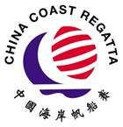
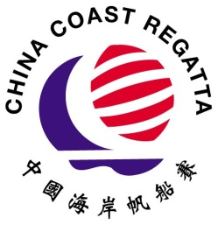
PROTEST TIME LIMITS
Date: 13 October 2019
IRC RACER 0 | 1602hrs
IRC RACER 1 | 1715hrs
IRC RACR 2 | 1624hrs
IRC RACER 3 | 1637hrs
IRC PREMIER | 1637hrs
HKPN MONOHULL | 1659hrs

